Term | Autumn 1  2023 | Autumn 2  2023 | Spring 1  2024 | Spring 2  2024 | Summer 1  2024 | Summer 2  2024
Topic/theme | All About Me  People Who Help Us  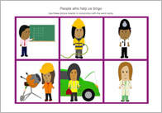 | Monsters  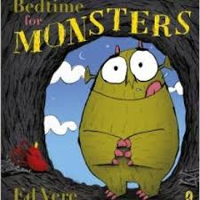  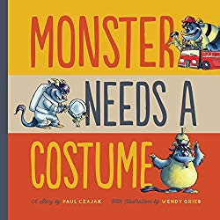 | On the Farm  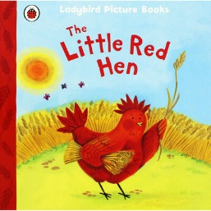  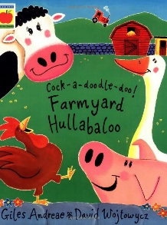 | Mini beasts  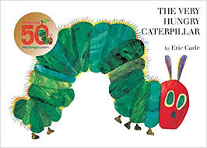  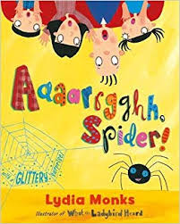 | 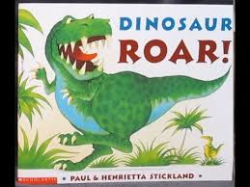  Dinosaurs  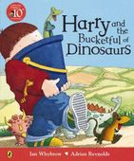 | Under the Sea  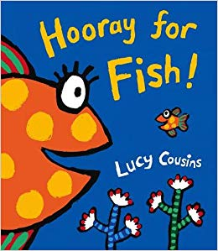  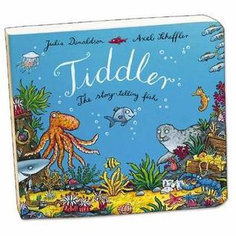
Key Texts | - Our bodies  - What I Like About Me  - Marvellous Me  - Eyes, Nose, Fingers and Toes | - Bedtime for Monsters  - Monster Needs a Costume  - Spider Sandwiches  - Quit Calling Me Monster | - Little Red Hen  - Farmyard Hullabaloo  - Peppa at the Petting farm  - How Big is a Pig? | - The Very Hungry Caterpillar  - Aaaarh Spider  - Mad About Mini Beasts  - Mini Beast Bop | - Harry and the Bucket Full of Dinosaurs  - Dinosaur Roar  - 10 Little Dinosaurs  - Dinosaurs Love Underpants | - Hooray for Fish  - Tiddler  - Barry the Fish with Fingers  - Fidgety Fish
- Fireman Sam
- Doc McStuffins
- Bob the Builder
- Peppa Pig Visits the Police Station
Special days/ events | - Diwali  - Black history month | - Bonfire night  - World kindness day  - Odd sock day -Anti bullying day  - Remembrance Sunday  - Children in need  - Christmas  - Nativity | - Chinese New Year  - Number day  - Child’s mental health week  - Safer internet day  - Shrove Tuesday  - Valentine’s day  - Random acts of kindness | - World book day  - Mother’s Day  - Red nose day  - Oral health day  - Easter  - Easer bonnet parade | - Kings Coronation  - World Earth day  - Eid al Fitr | - World Ocean day  - Kings Charles Birthday  - Father’s Day
Enrichment/ cultural capital | - Visit from emergency services | - Library visit story  - Nativity | - Dragon dance | - Trip to the farm | - Tea party | - Aqua lease  - Trip to the beach  - Sports day
Parent engagement | - Stay and play | - Stay and play  - Parents evening  - Parents watch Nativity  - Christmas activity day | - Stay and play | - Stay and play  - Mother’s Day  - Parents evening | - Stay and play | - Teddy bears picnic  - Stay and play  - Welcome meeting  - Sports day
Assessment opportunities | - Baseline assessment  - Wellcomm  - Data | - Data | - Data  - Baseline (new cohort) assessment  - Wellcomm | - Data | - Data  - Baseline (new cohort) assessment  - Wellcomm | - Data
PSED | - Settling in  - Rules/routines  - All about me  - Feelings/emotions  - Friendships  - Adults model play | - PSED interventions  - Reinforce rules/routines  - Adults model play | - Settling in  - PSED interventions  - Reinforce rules/routines  - Adults model play | - PSED interventions  - Reinforce rules/routines  - Adults model play | - Settling in  - PSED interventions  - Reinforce rules/routines  - Adults model play | - PSED interventions  - Reinforce rules/routines  - Adults model play
CL | - Nursery rhymes  - Daily story  - Talk time  - L/A skills  - Topic | - Nursery rhymes  - Daily story  - Talk time  - Topic  - Wellcomm intervention  - SALT intervention | - Nursery rhymes  - Daily story  - Talk time  - Topic  - Wellcomm intervention  - SALT intervention | - Nursery rhymes  - Daily story  - Talk time  - Topic  - Wellcomm intervention  - SALT intervention | - Nursery rhymes  - Daily story  - Talk time  - Topic  - Wellcomm intervention  - SALT intervention | - Nursery rhymes  - Daily story  - Talk time  - Topic  - Wellcomm intervention  - SALT intervention
PD | - Personal care  - Self-help skills  - Physical development (fine/gross)  - Pencil control  - Scissor grip | - Personal care  - Self-help skills  - Physical development (fine/gross)  - Pencil control  - Scissor grip/cutting skills | - Personal care  - Self-help skills  - Physical development (fine/gross)  - Pencil control  - Scissor grip/cutting skills | - Personal care  - Self-help skills  - Physical development (fine/gross)  - Pencil control  - Scissor grip/cutting skills | - Personal care  - Self-help skills  - Physical development (fine/gross)  - Pencil control  - Scissor grip/cutting skills | - Personal care  - Self-help skills  - Physical development (fine/gross)  - Pencil control  - Scissor grip/cutting skills
L | - Topic story books  - Adults model the class reading corner  - Book talk/skills  - Daily story time  - Nursery Rhymes  - L&Attention  - Environmental sounds  - Musical instruments | - Topic story books  - Adults model the class reading corner  - Book talk/skills  - Daily story time  - Nursery Rhymes  - L&Attention  - Environmental sounds  - Musical instruments  - RWI | - Topic story books  - Adults model the class reading corner  - Book talk/skills  - Daily story time  - Nursery Rhymes  - L&Attention  - Environmental sounds  - Musical instruments  - RWI | - Topic story books  - Adults model the class reading corner  - Book talk/skills  - Daily story time  - Nursery Rhymes  - L&Attention  - Environmental sounds  - Musical instruments  - RWI | - Topic story books  - Adults model the class reading corner  - Book talk/skills  - Daily story time  - Nursery Rhymes  - L&Attention  - Environmental sounds  - Musical instruments  - RWI | - Topic story books  - Adults model the class reading corner  - Book talk/skills  - Daily story time  - Nursery Rhymes  - L&Attention  - Environmental sounds  - Musical instruments  - RWI
M | - Counting nursery rhymes  - Adults modelling maths resources  - Comparing quantities many/few  - Counting in sequence  - Space (inset jigsaws/lid on teapot etc) | - Counting out from a larger group  - Recognising numerals  - Counting on fingers  - Patterns  - Building models/structures/  towers | - Comparing quantities more/fewer/the same  - Counting in sequence  - 1:1 correspondence  - Positional language  - Size/weight/capacity  - Shapes | - Number names  - Subitising to 3  - Number recognition  - Cardinality and composition  - 2D/3D shapes | - Numbers to 5  - Meaningful mathematical mark making  - Problem solving  - Patterns | - Number composition  - 1 more/less.  - Separates objects  - Reciting numbers forwards and backwards  - Patterns  - Shorter/lighter/  more/less  - Sequence everyday events
UW | - People and communities  - My family  - People who help us  - Customs and routines | - Seasonal changes  - Features of the environment  - Features of monsters  - Topic books | - Seasonal changes  - Features of the environment  - Farm animals  - Farm animal babies | - Seasonal changes  - Features of the environment  - Mini beasts  - Life cycle of butterfly | - Seasonal changes  - Features of the environment  - Sun safety | - Seasonal changes  - Features of the environment  - Sun safety
ExAD | - Adults model creative materials  - Self portraits  - Imaginary play  - Musical instruments | - Monster craft  - Christmas crafts  - Nativity performance  - Christmas songs  - Imaginary play  - Singing songs  - Creating models  - Exploring colour/creative | - Farm craft  - Imaginary play  - Musical instruments  - Singing songs  - Creating models  - Exploring colour/creative | - Mini beast crafts  - Mother’s Day cards  - Easter crafts  - Easter cards  - Imaginary play  - Singing songs  - Purposeful mark making  - Creating models  - Exploring colour/creative | - Dinosaur craft  - Imaginary play  - Singing songs  - Purposeful mark making  - Creating models  - Exploring colour/creative | - Sea creatures  - Imaginary play  - Singing songs  - Purposeful mark making  - Creating models  - Exploring colour/creative

Term | Autumn 1  2022 | Autumn 2  2022 | Spring 1  2023 | Spring 2  2023 | Summer 1  2023 | Summer 2  2023
Topic/theme | All About Me  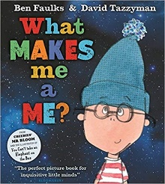  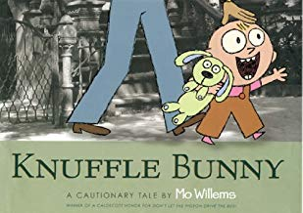  Toys | 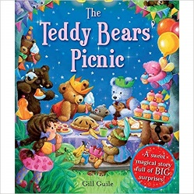  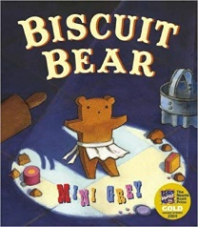  Bears | Celebrations  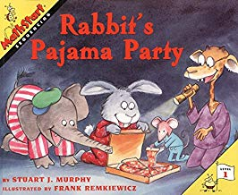  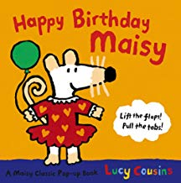 | Growing  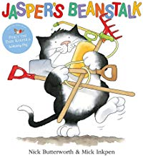  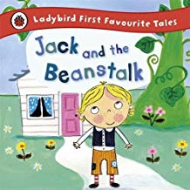 | 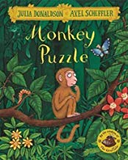  Zoo Animals  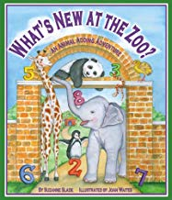 | 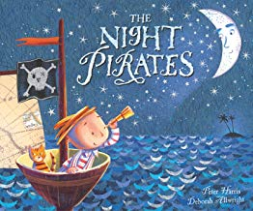  Pirates  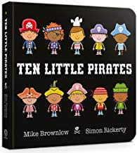
Key Texts | - What Makes Me me?  - I Like Myself!  - Incredible Me  - We’re Different We’re the Same | - Biscuit Bear  - The Teddy Bears Picnic  - Brown Bear, Brown Bear  - Polar Bear, Polar Bear  - We’re Going on a Bear Hunt | - Happy Birthday Maisie  - Rabbit’s Pyjama Party  - The Birthday Box  - Five Little Monkeys Bake a Birthday Cake  - If You Give a Pig a Party | - Jasper and the Beanstalk  - Jack and the Beanstalk  - The Tiny Seed  - The Surprise Garden  - Growing Vegetable Soup | - Monkey Puzzle  - What’s New at the Zoo  - My Zoo  - The Zoo’s Grand Opening  - Say Hello to the Jungle Animals  - Walking Through the Jungle  - Giraffes Can’t Dance | - The Night Pirates  - 10 Little Pirates  - That’s Not My Pirate  - Peppa Pig and the Treasure Hunt  - Portside Pirates
- Our bodies
- What I Like About Me
- Marvellous Me
- Eyes, Nose, Fingers and Toes
Special days/ events | - Diwali  - Black history month | - Bonfire night  - World kindness day  - Odd sock day -Anti bullying day  - Remembrance Sunday  - Christmas  - Nativity | - Chinese New Year  - Number day  - Child’s mental health week  - Safer internet day  - Shrove Tuesday  - Valentine’s day  - Random acts of kindness | - World book day  - Mother’s Day  - Oral health day  - Easter | - World Earth day  - Eid al Fitr | - World Ocean day  - Kings Charles Birthday  - Father’s Day
Enrichment/ cultural capital |  | - Library visit story  - Nativity | - Dragon dance? |  |  | - Aqua lease  - Trip to the beach  - Sports day
Parent engagement | - Stay and play | - Stay and play  - Parents watch Nativity  - Christmas activity day | - Stay and play | - Stay and play  - Mother’s Day | - Stay and play | - Teddy bears picnic  - Stay and play  - Welcome meeting  - Sports day
Assessment opportunities | - Baseline assessment  - Wellcomm  - Data | - Data | - Data  - Baseline (new cohort) assessment  - Wellcomm | - Data | - Data  - Baseline (new cohort) assessment  - Wellcomm | - Data
PSED | - Settling in  - Rules/routines  - All about me  - Feelings/emotions  - Friendships  - Adults model play | - PSED interventions  - Reinforce rules/routines  - Adults model play | - PSED interventions  - Reinforce rules/routines  - Adults model play | - PSED interventions  - Reinforce rules/routines  - Adults model play | - PSED interventions  - Reinforce rules/routines  - Adults model play | - PSED interventions  - Reinforce rules/routines  - Adults model play
CL | - Nursery rhymes  - Daily story  - Talk time | - Nursery rhymes  - Daily story  - Talk time  - Wellcomm intervention | - Nursery rhymes  - Daily story  - Talk time  - Wellcomm intervention | - Nursery rhymes  - Daily story  - Talk time  - Wellcomm intervention | - Nursery rhymes  - Daily story  - Talk time  - Wellcomm intervention | - Nursery rhymes  - Daily story  - Talk time  - Wellcomm intervention
PD | - Personal care  - Self-help skills  - Physical development (fine/gross)  - Pencil control  - Scissor grip | - Personal care  - Self-help skills  - Physical development (fine/gross)  - Pencil control  - Scissor grip/cutting skills | - Personal care  - Self-help skills  - Physical development (fine/gross)  - Pencil control  - Scissor grip/cutting skills | - Personal care  - Self-help skills  - Physical development (fine/gross)  - Pencil control  - Scissor grip/cutting skills | - Personal care  - Self-help skills  - Physical development (fine/gross)  - Pencil control  - Scissor grip/cutting skills | - Personal care  - Self-help skills  - Physical development (fine/gross)  - Pencil control  - Scissor grip/cutting skills
L | - Topic story books  - Adults model the class reading corner  - Book talk/skills  - Daily story time  - Nursery Rhymes  - L&Attention  - Environmental sounds  - Musical instruments | - Topic story books  - Adults model the class reading corner  - Book talk/skills  - Daily story time  - Nursery Rhymes  - L&Attention  - Environmental sounds  - Musical instruments  - RWI | - Topic story books  - Adults model the class reading corner  - Book talk/skills  - Daily story time  - Nursery Rhymes  - L&Attention  - Environmental sounds  - Musical instruments  - RWI | - Topic story books  - Adults model the class reading corner  - Book talk/skills  - Daily story time  - Nursery Rhymes  - L&Attention  - Environmental sounds  - Musical instruments  - RWI | - Topic story books  - Adults model the class reading corner  - Book talk/skills  - Daily story time  - Nursery Rhymes  - L&Attention  - Environmental sounds  - Musical instruments  - RWI | - Topic story books  - Adults model the class reading corner  - Book talk/skills  - Daily story time  - Nursery Rhymes  - L&Attention  - Environmental sounds  - Musical instruments  - RWI
M | - Counting nursery rhymes  - Adults modelling maths resources  - Comparing quantities many/few  - Counting in sequence  - Space (inset jigsaws/lid on teapot etc) | - Counting out from a larger group  - Recognising numerals  - Counting on fingers  - Patterns  - Building models/structures/  towers | - Comparing quantities more/fewer/the same  - Counting in sequence  - 1:1 correspondence  - Positional language  - Size/weight/capacity  - Shapes | - Number names  - Subitising to 3  - Number recognition  - Cardinality and composition  - 2D/3D shapes | - Numbers to 5  - Meaningful mathematical mark making  - Problem solving  - Patterns | - Number composition  - 1 more/less.  - Separates objects  - Reciting numbers forwards and backwards  - Patterns  - Shorter/lighter/  more/less  - Sequence everyday events
UW | - People and communities  - My family  - Toys  - Customs and routines | - Seasonal changes  - Features of the environment  - Features of bears  - Topic books | - Seasonal changes  - Features of the environment  - Celebrations – Christmas, birthday, Diwali, bonfire night, Halloween etc. | - Seasonal changes  - Features of the environment  - Growing  - Life cycle of a plant | - Seasonal changes  - Features of the environment  - Sun safety | - Seasonal changes  - Features of the environment  - Sun safety
ExAD | - Adults model creative materials  - Self portraits  - Imaginary play  - Musical instruments | - Bear craft  - Christmas crafts  - Nativity performance  - Christmas songs  - Imaginary play  - Singing songs  - Creating models  - Exploring colour/creative | - Celebration craft  - Imaginary play  - Musical instruments  - Singing songs  - Creating models  - Exploring colour/creative | - Growing crafts e.g. Jack and the Beanstalk  - Mother’s Day cards  - Easter crafts  - Easter cards  - Imaginary play  - Singing songs  - Purposeful mark making  - Creating models  - Exploring colour/creative | - Zoo craft  - Imaginary play  - Singing songs  - Purposeful mark making  - Creating models  - Exploring colour/creative | - Pirate craft  - Imaginary play  - Singing songs  - Purposeful mark making  - Creating models  - Exploring colour/creative

