Maths  Fractions  Children learn to understand parts and wholes, recognise and find simple fractions (½, ¼, ⅓, ¾), explore equivalence, and count in fractions up to a whole. | Year 2  Summer 1 term 2026  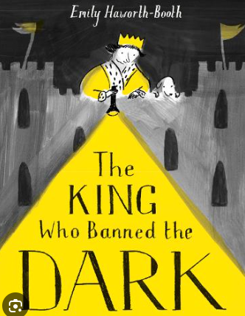 | English  The King who banned the dark.  Persuasive letter  Narrative story.
Science  Animals, including humans 2- Life cycles  Takes children through 6 lessons where they are taught how to notice that animals, including humans have offspring which grow into adults. | History  Modern Briton  Children learn about modern Britain by exploring recent history, key events, and significant people, helping them understand how life has changed over time and how it shapes the world they live in today. | Phonics  We will teach phonics daily using the Read Write Inc program.  Pupils will engage in daily phonics lessons and the pupils reading books will match their current phonics lesson.
Music  Charanga Music Scheme – Friendship song | Art  Sculpture and 3D: Clay (Rachel Whiteread)  Create a house design and plan how to create the key features in clay. | Computing
PSHE  My Happy Mind- Appreciate  How to develop an attitude of gratitude. | PE  Games  Throw, kick dribble with balls. Thinking about direction and speed. | RE  Me and families and friends  Children show an understanding of belonging, and how and why this is important. Children reflect on what qualities others have to offer and those which are considered ‘good’.

